New England Rural Health Association (NERHA): Building Rural Workforce Capacity Through Network-Based Training Models
Erin E. Sullivan, PhD
Contributing Site Leaders
Ann Marie Day, COO
Andy Lowe, CEO
New England Rural Health Association

Site and Regional Snapshot
The New England Rural Health Association (NERHA) serves as a regional collaborative organization spanning six states: Maine, New Hampshire, Vermont, Connecticut, Rhode Island, and Massachusetts. This region encompasses significant geographic diversity including the far north, mountainous communities, and isolated islands, with rural counties comprising 10% to 93% of the counties per state. Rural New England faces unique demographic challenges that intensify workforce demands. Maine, New Hampshire, and Vermont rank 1st, 2nd, and 3rd respectively in median age nationally, with Maine at 45.3 years, New Hampshire at 43.4 years, and Vermont at 43.2 years (all above the national average of 39.1). These states are aging faster than the rest of the country, creating mounting pressure on an already stretched healthcare workforce (see Table 1 for regional characteristics).
The region faces typical rural challenges that compound workforce shortages. Limited public transportation makes commuting to work or to access healthcare difficult, especially for low-wage workers without private transportation options (see Figure 1 for hospital access disparities across the region). Inadequate broadband and cellular service in many areas constrains telehealth expansion and virtual learning opportunities. Significant healthcare workforce scarcity affects all provider categories, from physicians and advanced practice providers to allied health professionals and community health workers. However, the existence of robust Medicaid reimbursement structures, particularly in Massachusetts and Rhode Island, combined with established Area Health Education Center (AHEC) networks, provides a foundation for workforce innovation that many rural regions lack, although looming federal Medicaid cuts threaten coverage.

NERHA Profile
NERHA operates as a regional facilitator, and the only regional rural health association, acting as the connective tissue coordinating partnerships among rural community health centers (FQHCs), Critical Access Hospitals (CAHs), AHECs, community-based organizations (CBOs), community colleges, academic institutions, and State Offices of Rural Health. This networked approach enables collaboration that individual organizations struggling with resource constraints could not achieve independently.

Innovation #1

Workforce Challenge and Pre-Intervention State
Healthcare workforce gaps produce cascading negative impacts throughout rural New England communities. Extended travel distances for basic care mean that minor health concerns often go unaddressed until they become major problems requiring emergency intervention. Community health workers (CHWs) are an efficient and cost-effective resource to counter these trends, serving as bridges between healthcare systems and the communities they serve. In rural New England, however, the CHW workforce is insufficient in size, distribution, and linguistic/cultural diversity. Where CHWs are present, they provide critical cultural concordance because they frequently share the cultural, linguistic, racial, and ethnic backgrounds of the populations they serve. This shared experience allows them to build trust and offer empathetic care that keeps people connected to healthcare systems, promotes preventive care and early intervention, and reduces reliance on crisis-only service use.

Workforce Innovation: Community Health Worker Training Program
Recognizing these interconnected challenges, NERHA developed and implemented the Massachusetts Rural Public Health Workforce Training Network, a comprehensive community health worker training and placement program. The program was specifically designed to recruit, train, and place CHWs into rural healthcare positions and create a sustainable CHW pipeline.
The program pursued five interconnected objectives. First, it sought to recruit migrant and immigrant community members for CHW training, reaching into communities that healthcare systems had historically failed to engage. The region supported a substantial but often "invisible" workforce-aged migrant and immigrant workforce employed in the tourism, hospitality, and agriculture sectors. To attract these workers, the program clearly articulated career pathways and earning potential, showing that CHW roles could offer salaries starting around $48,000 compared with approximately $35,000 in housekeeping, a 37% income increase that could transform family economic stability as well as strengthen local economies. Second, it aimed to provide accessible, culturally responsive training with financial support that removed economic barriers to participation. Third, it sought to create sustainable career pathways into healthcare for underserved populations, recognizing that one-time training without advancement opportunities leads to burnout and turnover. Fourth, it prioritized expanding the rural CHW workforce in communities with the greatest need. Finally, it committed to building a replicable pipeline model that could be adapted across New England, using shared tools and lessons learned.
Several core principles guided program design and implementation. Community-centered recruitment through trusted community-based and cultural organizations acknowledged that immigrant communities, often wary of government institutions, respond more readily to invitations from organizations and individuals they already trust. Barrier reduction through stipends, English as a Second Language (ESL) support, and free training recognized that intent alone is insufficient without practical supports. A “grow our own” approach to workforce development assumed that residents bring a stronger commitment to place than external recruits. Cultural and linguistic concordance between CHWs and the populations they serve was treated as an essential design feature, not a secondary benefit with some trainees continuing on to medical interpretation training. Finally, network-based collaboration leveraging AHECs, community colleges, and rural employers distributed responsibilities and costs, making the program sustainable in ways that would not be possible for a single organization acting alone.
The program secured funding through the HRSA Federal Office of Rural Health Policy’s (FORHP) innovative Rural Public Health Workforce Training Network (RPHWTN) grant, which provided the financial foundation for barrier removal and program implementation.

Program Design and Implementation

Governance and Leadership Structures
NERHA's role as central coordinating organization proved essential to program success. Rather than attempting to build new training infrastructure or compete with existing organizations, NERHA served as network convener and facilitator across multiple partner organizations. The organization provided strategic planning and program design, managed grant administration and reporting, developed cross-sector partnerships, and disseminated best practices across the network and beyond. This facilitation role allowed NERHA to leverage existing organizational strengths while filling coordination gaps that prevented effective collaboration. The governance model emphasized horizontal collaboration rather than hierarchical control. NERHA convened regular meetings where partners planned the program, shared challenges, celebrated successes, and adapted implementation strategies collectively. When barriers emerged (e.g. regulatory hurdles, curriculum gaps, or employer concerns), the network problem-solved together rather than leaving individual organizations to struggle alone.

Program Components and Practices
The training itself built deliberately on what partners were already doing well. Community colleges in the network had strong existing CHW curricula, and the project team worked with them to “infuse more rural content” into the curricula so that it made sense in small, remote communities rather than only in urban settings. Courses were offered in flexible formats (e.g. hybrid, in-person, and virtual) and were scheduled during evenings and other off-hours so that students working in tourism, hospitality, housekeeping, and other jobs could participate without giving up their income. The community colleges offered courses open to students across different regions to expand access and opportunities to all students in the program. The program was designed not only to grow the overall CHW workforce, but also to upskill people already working in CHW roles. To that end, the team added cross-training modules in billing and coding, peer recovery and support services, and core behavioral health and mental health treatment concepts, equipping both new and incumbent CHWs to function more effectively in rural primary care and community-based settings.
Language support integrated ESL services as needed throughout training. Sixty percent of trainees spoke a language other than English at home (e.g., Spanish, Portuguese, French/Haitian Creole), making language accessibility essential rather than optional. Rather than requiring English proficiency before entry, the program integrated language support into training, recognizing that healthcare-specific English could be learned alongside clinical content.
Financial support included student stipends up to $500 per trainee to offset costs for travel, childcare, technology, and other barriers that would otherwise prevent participation. Free training eliminated tuition barriers for all participants, ensuring that economic constraints did not determine who could access healthcare career pathways.
Training without employment leads nowhere, so NERHA and AHECs cultivated relationships with rural FQHCs, CAHs, and community health centers committed to hiring trained CHWs. Career laddering created clear pathways for professional growth beyond initial CHW positions, demonstrating that CHW positions were launching pads rather than endpoints. In addition, network members met with employers beyond “traditional” healthcare operations (e.g., libraries, law enforcement, social services) to educate them about the skill sets that CHWs can offer.

Partnerships and External Relationships
The core partnership structure brought together organizations with complementary capabilities. The Massachusetts State Office of Rural Health provided policy support and connections to state-level resources, helping navigate regulatory requirements and advocating for policy changes that supported CHW workforce development. MassHealth’s best-in-class Medicaid CHW reimbursement policies created sustainable payment models for employing organizations, ensuring that CHW positions could be sustained beyond grant funding. Massachusetts AHECs provided training infrastructure, preceptor relationships with healthcare employers, and deep community connections built over years of workforce development work. Community-based organizations conducted targeted outreach to migrant and immigrant communities, provided cultural navigation services, and built bridges between immigrant populations and healthcare institutions. Community colleges delivered curriculum and certificate pathways, bringing instructional expertise and academic credibility. Massachusetts Association of Community Health Workers certifies new CHWs based on hours of supervised work experience in addition to the completed academic certificate.

Infrastructure and Sustainability Elements
NERHA emphasized data capture, analysis, evaluation, and dissemination as essential for program sustainability. By rigorously tracking recruitment numbers, training completion rates, employment outcomes, and wage progression, the program built an evidence base demonstrating impact. This data proved essential for communicating outcomes to funders, securing future funding, refining program design based on evidence, and supporting sustainability planning. One key element was pairing quantitative results with qualitative storytelling, making the data more accessible and compelling for lay audiences, including lawmakers.

Early Outcomes and Impact
The program trained over 200 students in CHW skills and competencies across 35 courses delivered over three years, demonstrating both scale and sustained implementation. Sixty percent of trainees spoke a language other than English at home, directly addressing the need for culturally and linguistically concordant CHWs. Twenty-five percent of trainees were hired or promoted following training completion, a placement rate that transformed training investment into actual workforce expansion. Importantly, 56% of trainees were not currently working as CHWs when entering the program, representing net new workforce additions rather than simply credentialing existing workers (see Table 1 for CHW training program outcomes).

Innovation #2

Workforce Challenge and Pre-Intervention State
New England faces a large-scale substance use crisis, particularly in rural communities where healthcare access challenges and social isolation compound behavioral health needs. A significant workforce shortage of behavioral health providers exists across Vermont and New Hampshire, with rural areas bearing the most severe gaps. The deficit is particularly acute among prescribers trained to treat substance use disorders using Medication-Assisted Treatment (MAT), the evidence-based approach combining medications like buprenorphine with counseling and group behavioral therapies. Limited specialized behavioral care services in rural areas mean that individuals experiencing substance use disorders (SUD) often have nowhere to turn except emergency departments (ED), which provide crisis stabilization but not ongoing treatment. This in turn stresses the EDs and hospitals, which already have insufficient beds for emergent and routine inpatient needs. Insufficient rural community care infrastructure means that even motivated individuals seeking treatment face months-long waiting lists or must travel hours to access services, barriers that frequently prevent individuals from ever beginning treatment.

Workforce Innovation: Behavioral Health and Substance Use Disorder PA Training Program
Building explicitly on the success of the CHW network model, NERHA launched the Northern Border Rural Behavioral Health Workforce program, a cross-border initiative training physician assistant (PA) students in behavioral health and SUD treatment for placement in rural Vermont and New Hampshire communities. Recognition that Advanced Practice Providers (APPs) have higher rural retention rates than physicians shaped the program's focus on PA rather than physician training, prioritizing the provider types most likely to remain in rural communities long-term.
The program secured $1.6 million in funding through the Rural Communities Opioid Response Program– Northern Border Rural Workforce Grant released through FORHP. The program’s goal is to train more than 100 PA students over four years in behavioral health and SUD care, including MAT, and to place them for clinical rotations and eventual employment in rural communities in Vermont and New Hampshire. Franklin Pierce University serves as the academic anchor, while the New Hampshire and Vermont AHECs coordinate placements and employer relationships.
Behavioral health and SUD content is infused across the PA curriculum, with enhanced didactic material in the first year and clinical experiences in the second, so that students see substance use and mental health as routine components of rural practice and primary care rather than niche subspecialties. The program aims to place PA students for clinical rotations in a range of rural settings, including EDs, community health centers, and recovery and treatment centers, so that each learner has a variety of rural experiences during training.
Because many rural practices are already understaffed, the program includes structured support for preceptor sites. Clinical sites can receive stipends of up to $1,500 to offset the time and productivity lost to teaching, on top of any existing tax credits or incentives they may access. AHECs have also developed a standardized preceptor training toolkit and provide ongoing technical assistance so that busy clinicians can integrate students into their practice. When clinicians feel well-supported, students are more likely to have positive clinical experiences. If students have good clinical experiences, feel welcomed by practice teams, achieve cultural fit with communities, and see opportunities for professional growth, they are more likely to accept positions at sites post-graduation. The recruitment-retention connection framed student supervision for C-suite members not as burden but as long-term workforce development investment, with preceptor sites essentially auditioning as potential employers throughout the training relationship.

Early Outcomes and Impact
Initial impacts from program inception include the creation of a formal rural health network among academic and AHEC partners that enables synergies to enhance rural workforce development. As a first-year program (as of the December 2025 presentation), the PA initiative had not yet produced graduate placement outcomes. Full workforce metrics including graduation rates, rural placement percentages, and retention rates will become available as cohorts complete training and enter practice in subsequent years. The program’s multi-year timeline means that workforce impact will emerge gradually.

Lessons Learned
NERHA’s experience across both programs reinforces several interconnected principles for rural workforce development. Most fundamentally, network-based coordination works: NERHA’s role as a neutral, trusted convener enabled cross-sector collaboration that no single organization could have achieved independently, reframing relationships around shared regional goals rather than institutional competition. The PA Training Program’s deliberate replication of the CHW model’s AHEC-network-community partner structure illustrates a second principle: when a governance model succeeds, adapt it rather than rebuild from scratch. Across both programs, rigorous data collection and qualitative storytelling were treated not as reporting obligations but as strategic tools for securing future funding and demonstrating impact to policymakers and lay audiences alike. Finally, sustainability planning began on Day 1 in both initiatives, with network design, evaluation infrastructure, and diversified funding strategies built in from the start rather than appended to grant applications.

Barrier: Community Health Worker Accreditation Complexity
Massachusetts’ requirement of 2,000 work hours before CHW certification created a classic catch-22: people needed experience to become certified, but many employers wanted certification before hiring. This structure effectively excluded many potential immigrant workers from the field. The program responded by training both new entrants and incumbent workers at the same time, showing that people could be effective in CHW roles even while they moved toward certification. The fact that 56% of trainees were not working as CHWs before entering the program illustrates that it successfully created new pathways rather than only upskilling existing staff. By leveraging MassHealth’s favorable CHW reimbursement policies, the team also made it more feasible for employers to hire workers who were on the path to formal certification.
The lesson here is to advocate for policy changes while simultaneously working within existing constraints. Waiting for perfect policy before implementation means never starting; working within constraints while building evidence for change enables both immediate action and long-term policy reform.

Barrier: Medicaid Reimbursement Variability
Medicaid reimbursement for CHWs differs substantially across New England. Massachusetts and Rhode Island have strong CHW coverage, while Vermont, New Hampshire, and Maine lag. As a result, many organizations still depend heavily on time-limited grants, which constrain scale and threaten continuity when those grants end. The CHW program confronted this by using results from Massachusetts to advocate for policy change in northern states and by pointing to Rhode Island’s state plan amendment as a best-in-class example. Leaders were candid that “a lot of people are still using grant funds to fund their CHWs” and acknowledged that churn in Medicaid could move things backward as well as forward.
NERHA realized that even with solid program performance, financial sustainability requires ongoing advocacy and diversification of funding sources. Building multiple revenue streams, rather than relying entirely on Medicaid or entirely on grants, reduces vulnerability when policies or funding priorities shift.

Looking Ahead
NERHA’s workforce innovations demonstrate that network-based, community-centered training programs can address multiple dimensions of rural workforce shortages simultaneously. Through two distinct but interconnected initiatives (community health worker training and behavioral health PA education), NERHA has created replicable models for rural workforce development that balance innovation with practical implementation. A key priority for NERHA will be tracking where CHW and PA trainees work three to five years after program completion, and how their presence affects access, quality, and equity in rural communities. At the same time, NERHA will need to convert grant-funded pilots into durable regional infrastructure by securing more stable funding streams, including expanded Medicaid support for CHWs in northern New England and sustained employer investment in rural training sites.

Table 1. NERHA Service Area: Regional Characteristics and CHW Training Program Outcomes
Indicator | Value | Source/Notes
Geographic Scope
States served | 6 (ME, NH, VT, CT, RI, MA) | Regional collaborative organization
Rural counties (range by state) | 10% to 93% | Wide variability across states
Service Access Disparities (e.g., % Pop. > 15 miles to Any Hospital) | 0% to 63% | Wide variability by rural vs. urban county
New England total population | ~15.4 million | U.S. Census Bureau, July 2024
Workforce & Training Outcomes: CHW Training Program (3 years)
Students trained | 200+ | CHW skills and competencies
Training courses delivered | 35 courses | Includes intro, intermediate, certification
Non-English speakers at home | 60% of trainees | Primary language other than English
Hired or promoted after training | 25% of trainees | Placement rate post-completion
New workforce entrants | 56% of trainees | Not working as CHWs before program

Figure 1. Percentage of population living more than 15 miles from any hospital, by New England county
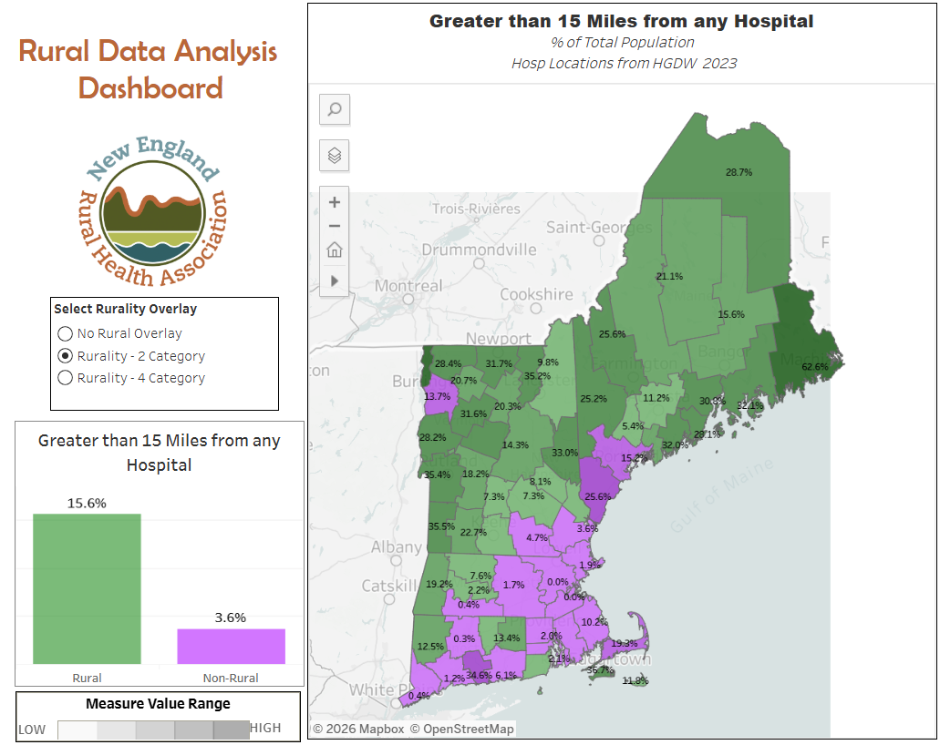
Works Consulted
Health Resources and Services Administration. (2024). Rural America at a glance: 2024 edition.
Health Resources and Services Administration. (2024). Rural Communities Opioid Response Program (RCORP): Northern Border Rural Behavioral Health Workforce grant overview.
Massachusetts Executive Office of Health and Human Services. (2024). MassHealth community health worker services: Coverage and billing guidance.
New England Rural Health Association. (2025). Empowering Massachusetts’ rural communities: Workforce training network results [Press release].
New England Rural Health Association. (2025, December 5). Rural workforce programs: Community health workers and behavioral health PAs [Conference presentation]. Rural Workforce Innovation Summit, Hutchinson, KS.
Rhode Island Executive Office of Health and Human Services. (2024). Medicaid enrollment and reimbursement for community health workers.
United States Census Bureau. (2024). QuickFacts: Maine; New Hampshire; Vermont; Massachusetts; Rhode Island; Connecticut; United States.
United States Census Bureau. (2025, June 25). An aging nation: U.S. median age surpassed 39 in 2024. https://www.census.gov/library/stories/2025/06/metro-areas-median-age.html
University of Massachusetts Donahue Institute. (2025). Summary of U.S. Census Bureau’s 2024 county characteristics estimates for Massachusetts.
NERHA Funding Note: The CHW Training Program and Behavioral Health and Substance Use Disorder PA Training Program are supported by the Federal Office of Rural Health Policy (FORHP), Health Resources and Services Administration (HRSA), U.S. Department of Health and Human Services (HHS) under Grant ID TR149328 and G62551, respectively. The information, conclusions, and opinions expressed on this page are those of the authors, and no endorsement by FORHP, HRSA, or HHS is intended or should be inferred.

