Southwest Health System: A Community Asset-Based Approach to Physician and Advanced Practice Provider Recruitment
Mark Deutchman, MD
Contributing Site Leaders
Dr. Jennifer Gero, CMO
Joe Theine, CEO
Southwest Health System

Site and Community Snapshot
Cortez, Colorado, is in rural Montezuma County in southwest Colorado, within the Four Corners area where Colorado, Utah, Arizona, and New Mexico meet. The population of Cortez is about 9,000, with roughly 30,000 people living within a 30-mile radius in several smaller communities including Dolores, Mancos, Dove Creek, and Towaoc, along with additional connections into southeastern Utah. A distinctive regional feature is the presence of adjacent sovereign tribal nations, including the Ute Mountain Ute and Southern Ute Tribes.
The population of Cortez itself is 62% White, 19% two or more races, 9% Black, and 2% Native American, with a median age of 36–39 years and a median household income of about $55,000. The poverty rate is around 15%, and the community faces a significant housing shortage, reflected in a very low vacancy rate and a 44% rise in median home price between 2020 and 2025. Major economic drivers include retail, healthcare and social services, construction, agriculture, and ranching, complemented by a growing outdoor recreation and tourism sector anchored by mountain biking, nearby national parks in Utah, and Mesa Verde National Park about 20 miles away, which attracts roughly 600,000 visitors each year; Telluride, Colorado, is about 90 minutes away, depending on weather and road conditions. Historically, Cortez has had a strong sense of community and has experienced modest growth. In addition to its public schools, Cortez has charter schools and a branch of a regional community college. Challenges to the entire region include water scarcity, access to broadband, high rates of chronic disease, and lack of public transportation.
Southwest Memorial Hospital, part of Southwest Health System, is an independent critical access hospital with 20 inpatient beds, of which 4 are ICU beds and 3 are part of a family birth center. It also operates an outreach clinic in Mancos, about 20 miles away, and a school-based health clinic at the local high school. Core services at the hospital include a level IV emergency department; general surgery, orthopedics, podiatry, maternity care including cesarean delivery; and supporting services such as laboratory, rehabilitation, infusion, and imaging. In 2025, the hospital reported approximately $80 million in net operating revenue. The Ute Mountain Ute Tribe operates its own primary care clinic in Towaoc, about 15 miles from Cortez (see Figure 1).
Geographic isolation is a defining challenge. The nearest larger town is Durango, Colorado (population about 20,000), located 54 miles away and accessible only by a two-lane, higher-elevation highway that can be significantly affected by winter weather. Durango has an 82-bed hospital in the CommonSpirit network that offers additional subspecialty services and more complex inpatient care. The closest major referral center is in Grand Junction, Colorado, nearly a four-hour drive away across multiple mountain passes, and the nearest academic medical centers are in Albuquerque, New Mexico (about a four-hour drive) and Denver, Colorado (about a seven-hour drive), all reached via two-lane roads with substantial geographic barriers.

Workforce Challenge and Pre-Intervention State
Southwest Memorial Hospital is independent and has a small tax base. From 2013 to 2023, the organization experienced considerable leadership instability, with seven different CEOs in either permanent or interim roles and multiple changes in chief financial officers. When the current leadership team arrived in mid-2023, the hospital had several years of operating losses in the $1M to $4M range. Cash was relatively low, with days of operating cash on hand falling short of bond debt covenants and raising the prospect of bondholders assuming a more active role in management.
Governance capacity was also strained. The hospital’s board had multiple vacancies, and the remaining members were in various late stages of their terms, creating uncertainty and limited continuity in oversight. At the same time, the medical staff was unstable, with looming departures of five physicians and heavy reliance on locum tenens physicians. Nursing retention was at a low of approximately 65%, with 24 open nursing positions and a recognized wage gap relative to regional markets contributing to nurse out-migration.
Hospital leadership characterized their challenge as follows:
We were not thriving, and we absolutely had to do something different, and why? Because we needed to increase access to patient care, we had to reduce our expense on locums, which in turn we could reinvest back into staff wages. We needed to change, and we needed to change not only the way the hospital recruited, but also the way the community recruited.

Workforce Innovation: Community Asset-Based Approach to Physician and Advanced Practice Provider Recruiting
In response, Southwest Memorial Hospital adopted a community asset–based approach to physician and advanced practice provider recruitment and retention, explicitly framing workforce stabilization as a shared responsibility across hospital leaders, clinicians, and community members. The board charged the CEO with rapidly filling nine key physician positions: two family medicine physicians with maternity care skills (FM/OB), one additional family medicine physician, two internal medicine physicians for ambulatory care, a hospitalist, a general surgeon, additional emergency physicians, and a podiatrist. These positions were chosen to expand access to core services, decrease dependence on high-cost locums, and create room in the budget for competitive nursing wages.
Rather than relying solely on external recruiters and standard site visits, leadership designed internal structures and processes that highlighted local strengths, empowered practicing physicians in recruitment, and personalized each candidate’s introduction to the community. They paired these physician-focused efforts with deliberate investments in nursing compensation and culture, viewing physician and nursing stability as mutually reinforcing pillars of the hospital’s long-term viability.

Design and Implementation

Governance and Leadership Structures
A central early step was to create a recruitment and retention task force that was explicitly physician-led and included multiple physicians, key hospital stakeholders, and the CEO. Calling it a task force signaled urgency and a clear mandate to accomplish tangible changes in a relatively short time frame. The task force used a shared SharePoint site to track all candidates, including who was in the pipeline, where they were in the process, and what follow-up was needed, giving members a common, transparent information base.
The hospital simultaneously formalized a CEO–Chief Medical Officer (CMO) dyad to bridge communication between clinicians and leadership and to model shared decision-making. The CEO invited a respected emergency physician who had been serving as a medical director to co-design the CMO role, encouraging her to talk with CMOs at similar hospitals, define the responsibilities, and then return with a job description that made sense for their size and context. This approach signaled genuine partnership rather than a top-down definition of physician leadership. In the CEO–CMO dyad, transparency became a guiding principle, illustrated by creation of a recruitment scorecard that tracked the number of candidates in the pipeline, interviews completed, offers extended, and offers accepted, and made these data visible to physicians, the board, and other stakeholders whether the news was favorable or not. As the CEO explained, “… over the first 18 months of our effort … we talked to or had over 100 people interested in talking to us about job opportunities.”
Leadership also committed to pushing decisions as close as possible to the point of care rather than centralizing authority in the CEO’s office. This meant encouraging clinical dyads and frontline teams to make operational decisions, even when it created short-term friction, in service of a culture where clinicians felt genuine ownership of processes and outcomes.

Program Components and Practices
The task force began by updating the recruitment website and job listings so they more clearly described the hospital’s mission, community setting, and expectations for new clinicians, including the reality of geographic isolation and the hospital’s intent to build a collaborative culture. Recruitment practices were redesigned so that practicing physicians played central roles in interviews and candidate visits, instead of treating recruitment as primarily an administrative or recruiter-driven function.
Site visits were intentionally reshaped to showcase both the professional environment and the lived experience of the community. Many recruitment dinners and events were held in physicians’ homes, where candidates and their families could share home-cooked meals and informal conversations with potential colleagues. Physicians and community members, rather than realtors, led tours of schools, recreation areas, and neighborhoods, emphasizing authentic perspectives over purely transactional housing information. When candidates brought family members, the hospital and community hosts arranged activities and dinners that allowed spouses and children to participate without needing childcare and to experience what it might feel like to live in Cortez. Leaders emphasized that they were not just recruiting a clinician but welcoming a whole family into the community.
There was also a strong emphasis on seeking candidates who were a good fit for the culture they wanted to build, rather than simply filling positions. The CEO explained: “…we didn’t offer everybody a position if we brought them out to interview. … we were very intentional from day one about building a culture for our future, and being thoughtful about who we were going to invite in.” This was illustrated by the story of an applicant who declined a job offer based on unrealistically high salary expectations and took a job in a different community. When that job did not work out and the applicant asked if the Cortez job offer was still open, the CEO declined the applicant explaining “… we want people that are coming to our community that want to be a part of something, not that want to extract a dollar out in exchange for something that they’re bringing.”
Onboarding and retention practices were strengthened in tandem with recruitment. New clinicians received structured follow-up check-ins with the CMO and other leaders to discuss what was working well, what challenges they were encountering, and how the organization could support them more effectively, especially for those who were new to practice or to rural settings. Each new provider was assigned two mentors: a clinical mentor to support development in their practice setting and a community mentor to help them connect with local networks, schools, and activities that matched their interests. Regular “Cases and Desserts” sessions provided a recurring forum for clinicians to review challenging cases, learn together, and build social cohesion within the medical staff.
Recognizing that nursing turnover and wage gaps were undermining the physician environment, the hospital also tackled nursing workforce issues directly. Leadership measured local market wage gaps and then made a significant, proactive investment in nursing wages to achieve equity with the regional market, even before savings from reduced locums and contract staffing were fully realized. They understood that without competitive wages, culture initiatives alone would not be sufficient to retain nurses or create a stable, welcoming environment for new physicians.

Early Outcomes and Impact
The interventions resulted in significant positive early outcomes for both physician and nursing staffing. Two physician recruitment firms were used to identify potential candidates. About one-fourth of the 106 candidates were interviewed. Rapid physician contracting brought on physicians within 15 months, building confidence in the process. Seventeen of the 18 physicians who were offered contracts accepted, resulting in all nine of the original empty positions being filled (see Figure 2). Within 18 months, the nurse retention rate surpassed 90%, which placed the hospital the 90th percentile nationally. The nurse retention rate has been maintained between 80% and 90%. Based on decreased locum tenens use, decreased contract nursing use, and increased patient volume, the organization turned an operating loss into net income over a period of 12 to 18 months.
Southwest Health System’s recent financial results show a clear turnaround from operating losses from 2021-2023 to gains of $1.7M in 2024 and $2.2M in 2025, indicating meaningful fiscal improvement. This shift from multi-year losses to consecutive operating gains suggests the organization is building stronger financial stability and is better positioned to sustain its operations going forward (see Figure 3).

Clinical and Access Outcomes
Hospital and community stakeholders made the decision that preserving maternity care services is essential despite financial considerations, for several reasons. One is so that families do not have to travel over an hour away for care given the weather and geographic hazards. Equally important is the community’s view of the hospital as a full-service entity they can be proud of for care across the lifespan. To accomplish this, they prioritized recruitment of family medicine physicians with maternity care interests and skills (FM/OBs). They recognized that this meant recruiting a critical number of these physicians to share the 24/7/365 work required without creating burnout. It was also recognized that broadly-trained family medicine physicians can be flexibly integrated into ambulatory, inpatient, adult, pediatric, scheduled, and urgent/emergency care as patient care demands change over time. Behavioral health remains a significant challenge, as in many rural areas, but the regional federally qualified health center continues to play a central role in providing behavioral health services.

Lessons Learned
Leaders at Southwest Health System emphasized that effective recruitment and retention in rural settings must be understood as collective work rather than the responsibility of a single recruiter or department. They found that visible buy-in from clinicians, executives, and community members, manifested in physician-led task forces, community-hosted dinners, and clear roles for local partners created a sense of shared ownership that made recruitment more effective and sustainable.
Consistency in processes and expectations emerged as another key lesson. The organization ultimately codified its approach in a written recruitment process that outlines roles and expectations for hospital leaders, clinicians, and community hosts, framing this not just as today’s practice, but as “how Southwest recruits” going forward. Leaders also came to see recruitment and retention as a continuum: investing in ongoing mentorship, check-ins, culture work, and compensation is necessary to preserve momentum, maintain clarity of roles, and prevent a slide back into staffing crisis patterns.
Finally, Southwest’s experience highlighted the importance of treating people humanely, including when the fit is not right. When one new physician realized that Cortez was not the right place for his family, the CEO invited an honest conversation and worked toward a peaceful separation that respected both the clinician and the community’s needs. That approach preserved an abundance of goodwill such that the departing physician helped identify a successor from his residency program, and the hospital filled the vacancy with minimal disruption. Leaders see this as emblematic of the culture they aim to build: one in which relationships and integrity are prioritized, even in difficult circumstances.

Looking Ahead
With core medical and nursing staff more stable, Southwest Health System is actively exploring regional partnerships to build a more resilient workforce across the Four Corners area. One concept under discussion is a shared staffing arrangement in which neighboring hospitals collaborate to hire slightly more physicians than each individual site strictly needs, creating a “deeper bench” that can cover vacancies, vacations, parental leave, and unexpected departures without immediately turning to external locums. Making such a model work would require advance credentialing, aligned policies and procedures, and practical supports such as temporary housing for rotating staff.
The organization is also renewing its focus on pipeline development. Southwest has a long-standing, though intermittent, relationship with the University of Colorado School of Medicine’s rural program, in which medical students with an interest in rural practice spend much of their core clinical year in Cortez, and leaders plan to expand teaching once the medical staff is fully stabilized. They are considering re-establishing family medicine residency rotations, recognizing that residents can serve as a near-term recruitment source, and are exploring opportunities to host nursing students and other health professions learners in partnership with regional community colleges.
Sustaining and deepening the CEO–CMO dyad is viewed as central to maintaining the culture shift toward shared leadership and decisions made close to where care occurs. At the regional level, leadership development collaborations with the federally qualified health center, specialty surgical center, and CommonSpirit hospital in Durango are being designed to keep emerging leaders in the region even if they move between organizations. As the CEO notes, he would rather have competitors “take our talent and still work together” than see experienced leaders leave the region entirely and introduce new instability into neighboring institutions that share patients with Cortez every day.

Figure 1: Geographic Location of Cortez, CO
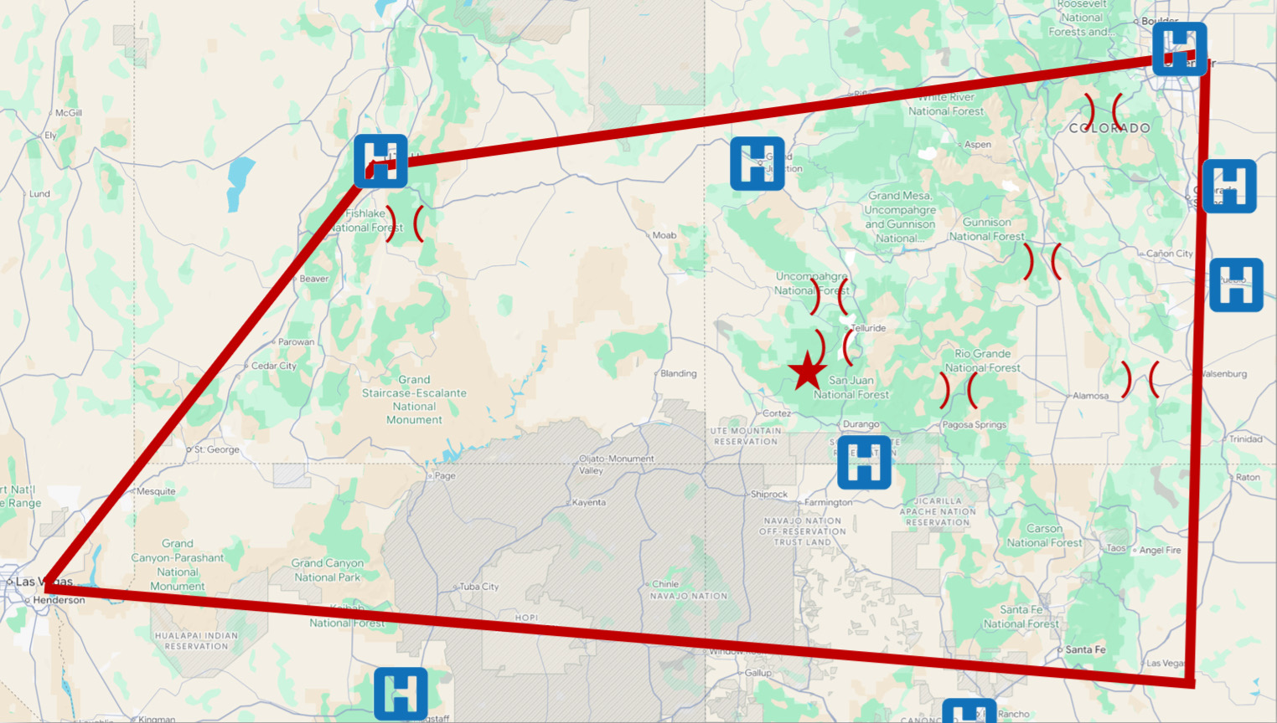
Notes: Geographically, *Cortez is in the center of four interstates; to access three of the four interstates, must traverse one or more mountain passes. Most larger/more capable hospitals are located along the interstates, not within.
Figure 2: Physician Recruitment Results and Dashboard
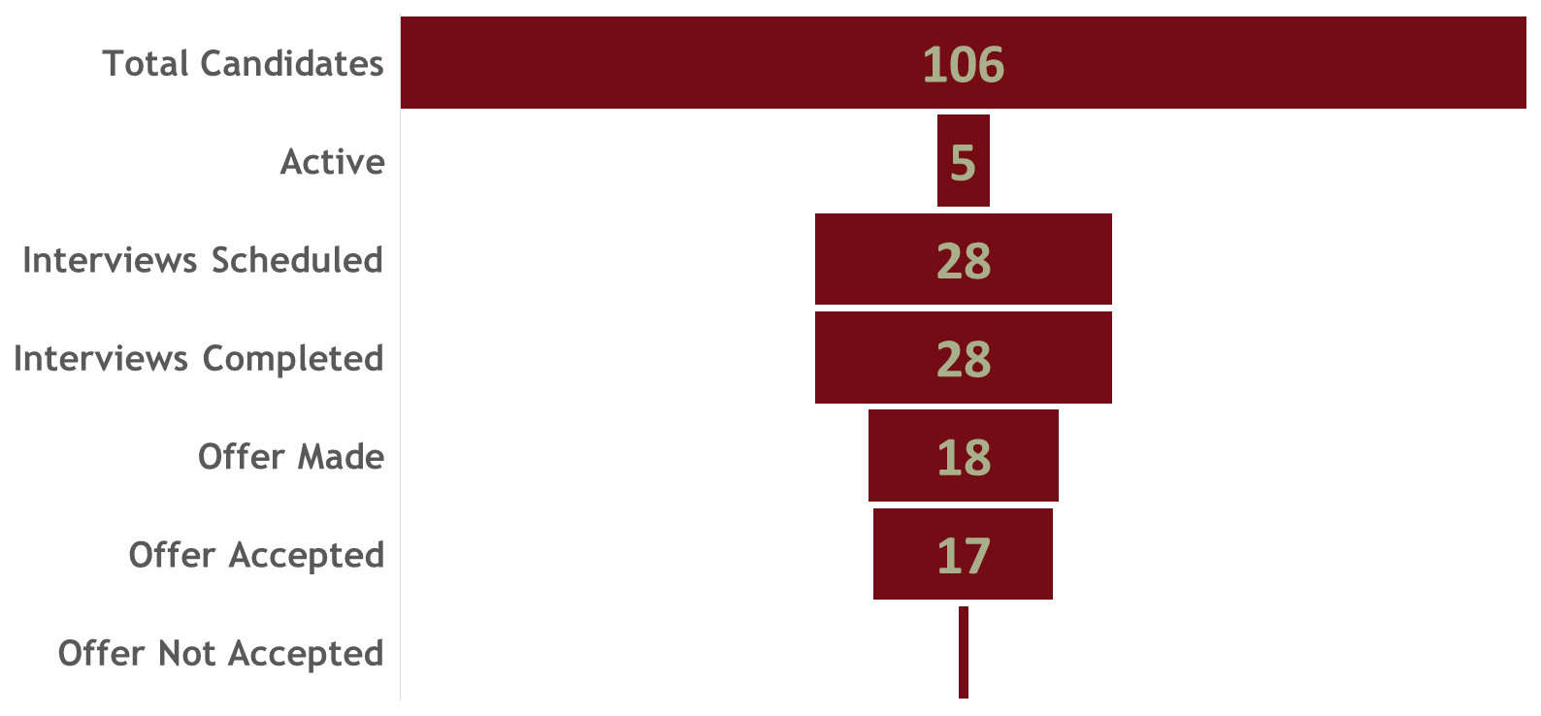
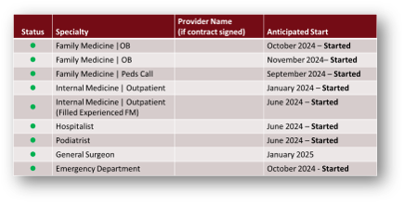

Figure 3: Fiscal Stability
